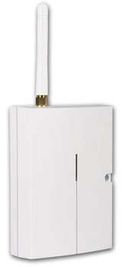

DAViD provides:
- 2 output contacts of power relays X and Y (each allows up to 5A/250V)
- 4 input terminals A to D for SMS reporting (the inputs react to a connection or disconnection to or from a common GND terminal)

David can be used as:
- A switch with SMS remote control. SMS texts for switching particular terminals on/off are configurable.
- A time-switch which can be activated remotely via a mobile phone (the switch-on period is configurable from 1 second to 10 hours).
- A relay with dialling-in remote control. Up to 50 tel. numbers can be authorized for each relay. Because calls are not answered dialling-in control within GSM is free of charge. (David only checks the caller’s number and - if the number is authorized - responds with relay activation.) This can be used for parking latch control etc.
- A relay with validity-limited dialling-in remote control. Each authorized number can have a limit to the number of calls. When the call count reaches the limit the tel. number is de-authorized. This can be useful for pre-paid services such as e.g. parking. Any tel. number can be re-authorized via SMS by the administrator.
- An SMS reporter. Input A to D activations or deactivations can be reported by SMS and optionally confirmed by phone calls. Each input can have its own message texts and up to 8 tel. numbers programmed.

Specifications
Power supply | 11 - 13 V DC
Stand-by consumption | approx 20 mA
Max. consumption (during communication) | 500 mA
GSM band | E-GSM 850 / 900 / 1800 / 1900 MHz
RF output power | 2 W for GSM 850 / 900, 1 W for GSM 1800 / 1900
A, B, C and D input terminals | activated by a connection to GND
X1+X2 and Y1+Y2 output terminals | 2x NC contacts fused to max. 5 A / 250 V
Can be operated according to | VO-R/1/07.2005-14
Safety | EN 60950-1
EMC | EN 301489-7, EN 55022 and EN 50130-4
Radio transmissions | ETSI EN 301419-1 and EN 301511
Environment | II. indoor general (-10°C to +40°C)
Dimensions (without antenna) | 76 x 110 x 33 mm
GSM antenna | connected to SMA connector

Specifications
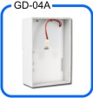 | A GD-04A back-up module, which provides David with the ability to work approx. 12 to 24 hours continually without an external power supply
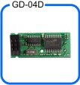 | A GD-04D DTMF module, which allows you to control David’s output relays by entering numeric codes (DTMF codes) on the telephone keypad during calls
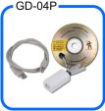 | A GD-04P link cable, which allows you to connect David to a PC through a USB port and perform any desired configuration using GDLink software.
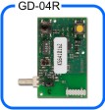 | A GD-04R radio module, which allows input A to D activations via wireless buttons or detectors of the OASiS series and also provides David with the capability of output relay X or Y state transmission to UC or AC OASiS receivers. In addition, you can control relays X or Y "locally" via RC-8x keyfobs (so that an appliance can be controlled both via a mobile phone and a keyfob). The module also allows heating control (again locally or remotely via a mobile phone) using wireless thermostats of the TP-8x series.

達因工控網 >> Http : www.umarket.com.tw
儀俵購物網 >> Http : www.smartmeter.com.tw

