Pt100Ω [ CONVERTER & DISTRIBUTTORS(SLIM TYPE )
SC-TR

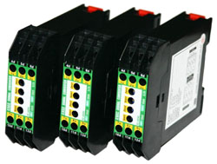

■FEATURE
Accuracy:+/-0.2% FS
Input Pt100Ω[ (3-wired) with 4 ranges selected via dip switch in one unit
Output V and mA selected via terminals and Output 0~5V/0~10V/1~5V/4~20mA/0~20mA selected via dip switch
Dual different signals output available
22.5 mm thin profile DIN rail mounting
Wide power supply range AC & DC 20 ~ 265V
CE approved

Http://www.umarket.com.tw
Http://www.smartmeter.com.tw

