pH/mV/Temp Meter
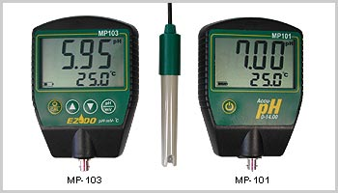
Model:
MP-103 pH/mV/Temp Meter
MP-101 pH Meter
Feature:
1. Microprocessor based with splash proof housing.
2. Simultaneous display pH and Temperature.
3. Automatic or manual temperature compensation. °C/°F switchable
4. Simple to calibrate by one keyboard for 3 points buffer.
5. Calibration value can be adjusted as needed.
6. Indicate percentage of slope (PTS) after calibration.
7. Low battery and consumption indicator.
8. Auto shut off after 10 minutes of non use.
9. Rubber protective holster with magnetic.
Specification:
 | MP-101 | MP-103
 | pH | pH | mV | Temp.
Range: | 0-14.00 | 0-14.00 | ±1999 | 0 -100°C
Accuracy: | 0.02 | 0.02 | 2 | 0.5°C
Resolution: | 0.01 | 0.01 | 1 | 0.1°C
Compensation: | MTC | ATC 0- 100°C
Calibration: | pH 4.00, 7.00, 10.00
Battery: | 9V
Dimensions: | 108 x 75 x 30 mm
Weight: | 135 g (with battery)
達因國際-Http://www.umarket.com.tw

