ORP-Pen type

pH, ORP, TDS, Cond, EC
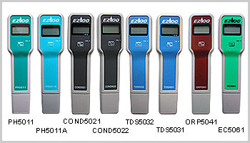
Features:
1. Fast response combined with High Accuracy.
2. Lightweight and compact.
3. Splash-proof membrane keypad.
4. Electrode can be extended up to 80mm.
5. Pocket clip moulded on the rear of the case.
6. Complete kit with electrode, screwdriver, battery, carrying case, standard solution (except ORP5041) and operating manual for use.
Specification:
 | PH5011 | PH5011A | COND5021 | COND5022 | TDS5031 | TDS5032 | ORP5041 | EC5061
 | pH | pH | uS/cm | uS/cm | ppm | ppm | mV | EC
Range: | 0-14.0 | 0-14.0 | 10-9990 | 0-999 | 10-9990 | 0-999 | ±999 | 0-20.0
Accuracy: | 0.2pH@25C | 0.02 | ±1%FS | ±1%FS | ±1%FS | ±1%FS | ±5%FS | 0.2
Resolution: | 0.1pH | 0.01 | 10 | 1 | 10 | 1 | 1 | 0.1
ATC | NO | YES | YES | YES | YES | YES | N/A | YES
Battery: | 9V | 1.5Vx3 | 9V
Dimensions: | Meter:158 x 40 x 34 mm, Carrying case: 165 x 100 x 40 mm
Weight: | complete kit: 255 g (Average)

ORP-Controller

pH/ORP Controller
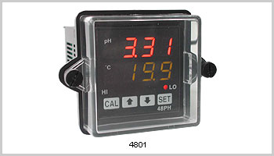
Features:
1. Compact 1/16 DIN size fits into standard industry panel cutouts.
2. Microprocessor for reliable, accurate measurement and control of pH.
3. Large and super bright LED display of pH(red) and temperature(green)
4. Rear screw terminals for power, 2 sets of relays, Pt 100 input and BNC for pH input.
5. Optional NEMA-4X gasketed lens cover fits over front bezel of controller-made of watertight corrosion resistant ABS plastic.
Specifications
 | 4801 |  | 4802
 | pH | Temp. | mV
Range | 0-14.00 | 0-100°C | ±1999
Resolution | 0.01 | 0.1°C | 1
Accuracy | 0.02 | 0.3°C | 2
Deadband | 2pH |  | 200mV
Compensation | ATC 0-100°C or MTC |  | N/A
Panel cutout | 1/16 DIN 1.77 x 1.77" (45 x 45 mm) Depth 4.2" (106 mm)
Power | 90 to 260 VAC, 50/60 Hz
Weight | 142g (5.0 oz)
達因國際Http://www.umarket.com.tw

