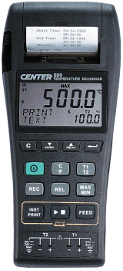 | CENTER 500 TEMPERATURE Graphic Recorder  - Dual input  - Dual display  - Text print out  - Graphic print out  - Easy setup with text menu  - RS-232 interface  - With Windows software  - 32,000 records data logger  - Auto power off  - Real time clock  - MAX/MIN function  - REL function  - Resolution 0.1ºC 0.1ºF  Measurement Range:  K Type:-200°C ~ 1370°C(-328°F ~ 2498°F)  J Type:-200°C ~ 760°C(-328°F ~ 1400°F)  Accuracy :  -200°C ~ 1370°C…. ±0.1% rdg + 0.8°C  -328°F ~ 2498°F…. ±0.1% rdg + 1.6°F  Input Protection:  60V DC or 24Vrms Maximum  Operation Temp: 0°C ~ 50°C  Storage Temp: -20°C ~ 60°C  Battery Life: Approx. 100 hours  Battery Type: Size AA 1.5V x 6 Alkaline Batteries.  Dimension:  242mm×98mm×42mm  Weight:  Approx. 580g  Accessory:  Manual, Carrying case, Battery, 9V Adapter, Thermal Paper, RS-232 Cable, Software, K Type bead sensor
From : Union Market – Dean Lu
(M 0932253026 )

