數位溫度指示計
(附”資料集錄功能”)

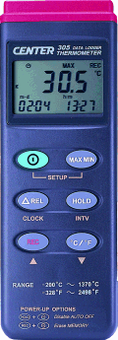 | CENTER 305 Data Logger Thermometer  - Triple Display  - Time Function  - RS-232 Interface  - With Window Software  - 16,000 Records Data logger  - Auto Power Off  - REL Function  - HOLD Function  - Resolution 0.1°C 0.1°F  Display :  3 1/2 digit LCD  Low Battery:  symbol will appear when the battery is low.  Measurement Range:  -200°C ~ 1370°C  -328°F ~ 2498°F  Accuracy :  -200°C ~ 1370°C…. ±0.3% rdg + 1°C  -328°F ~ 2498°F…. ±0.3% rdg + 2°F  Input Protection:  60V DC or 24Vrms AC Maximum  Battery:  9V, NEDA 1604, IEC 6F22, JIS 006P  Operation Temp.: 0°C~ 50°C  Storage Temp.: -20°C ~ 60°C  Dimension:  184mm×64mm×30mm( 7.25"×2.5"×1.2")  Weight :  Approx. 210g  Accessory:  Manual, 9V battery, Carrying case, K type bead sensor, RS-232 cable, Software

