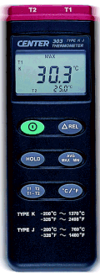 | CENTER 303 Thermometer  - K-Type J-Type  - Dual Input  - Dual Display  - Simulatneous MAX AVG MIN Measurement  - Auto Power Off  - REL Function  - HOLD Function  - Timer Function  - Resolution 0.1 °C,0.1°F  - External battery access door for easy battery changing  Display :  3 1/2 digit LCD  Low Battery:  symbol will appear when the battery is low.  Measurement Range:  K-Type -200°C~ 1370°C(-328°F~ 2498℉)  J-Type -200°C~ 760°C(-328°F~ 1400°F)  Accuracy :  -200°C ~ 1370°C…. ±0.1% rdg + 0.7°C  -328°F ~ 2498°F…. ±0.1% rdg + 1.4°F  Input Protection:  60V DC or 24Vrms AC Maximum  Battery Type:  9V, NEDA 1604, IEC 6F22, JIS 006P  Operating Temp.: 0°Cto 40°C( < 80% humidity )  Storage Temp.: -10°Cto 60°C( < 70% humidity )  Dimension: 184mm×64mm×30mm( 7.25"×2.5"×1.2")  Weight : Approx. 210g  Accessory:  Manual, 9V battery, Carrying case, K type bead sensor x 2

