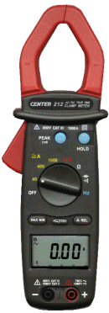 | CENTER 212 AC/DC CLAMP METER
- High Speed Bar Graph
- Measuring Range 1000A
- With 0.01 A Resolution
- DATA HOLD Function
- MAX / MIN function
- ZOOM function
- Relative function
- 1 ms Positive PEAK hold ,1 ms Negative PEAK hold
- Auto Ranging
Numerical Display :
3-3/4 digital LCD, maximum reading 3999.
Battery Life:
100 hr approx.(alkaline)
Low Battery Indication:
The is displayed.
Sampling Rate:
Digital:2 Times/sec;
Analog Bargraph:20 Times/sec.
Power Source:
9V battery( 6F22, 006P, 1604).
Auto power off:
30minute
Operating Condition :
0°C to 40°C(32°F to 104°F) < 80%RH.
Storage Condition:
-10°C to 60°C(14°F to 140°F) < 70%RH.
Dimensions:
242 ×66×36mm; 9.53”×2.60” ×1.42”
Weight:
Approx.500g
Accessories:
Carrying case, Battery, Manual & Test Lead

