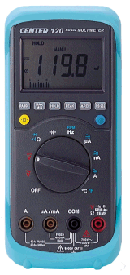 | CENTER 120 Auto Range Multimeter  - TRUE RMS  - LED back light  - "SlimComTM" RS-232 interface  - IEC 1010 1000V CAT III  - Auto Ranging  - High speed bar graph  - Auto power off  - With Windows software  - 1ms PEAK (max/min) function  - MAX/MIN function  - HOLD function  - REL function  - Capacitor measurement  - Temperature measurement  - Frequency measurement  - AC/DC 10A measurement  - Continuity measurement  - Diode measurement  - RPM measurement  Display:  3-3/4 digital(4000 count) display  Sample Rate:  2 times/sec for digital reading;  20 times/sec for analog bar indication  Battery Type:  9V, NEDA 1604, IEC 6F22, JIS 006P  Battery Life:  100 hours typical ( alkaline battery )  Operating Temp.:  0°Cto 40°C( < 80% humidity )  Storage Temp.:  -10°Cto 60°C( < 70% humidity )  Dimension:  198mm×86mm×38mm (7.8" ×3.4" ×1.5")  With holster:  209mm×94mm×48mm (8.2" ×3.7" ×1.9")  Weight:  Approx. 430g  Accessory:  Manual ,Test lead, 9V battery, Holster

