DC SIGNAL CONVERTER & DISTRIBUTTORS (Socket type)
NT-VA

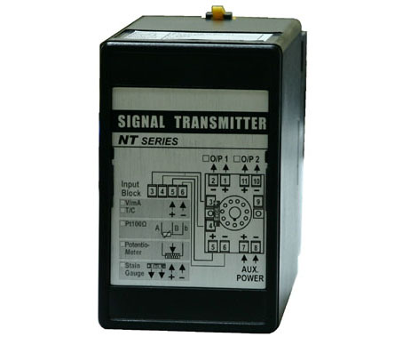
■FEATURE
Accuracy:+/-0.1% FS
Measuring DC current: 0~20mA / 5A, DC voltage: 0~50mV / 600V
6 Popular Input and Output Ranges Programmable by Dip-Switch
Input type changeable by difference Input Modules
Dual difference signal output available
Low cost and high stability
CE Approved

