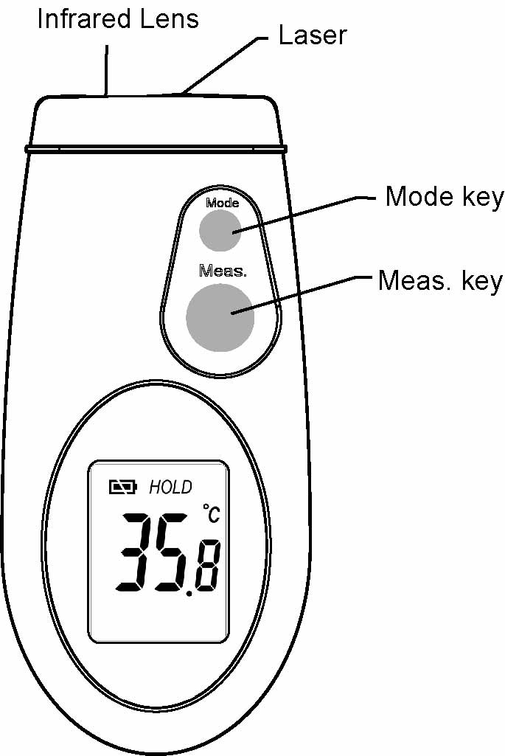
TN265/TN265L Thermometer Operating Instructions
(TN265 without Laser.)
The thermometer is a non-contact infrared thermometer. Simply aim the thermometer at the target and press the ‘Meas. key’ to display the surface temperature.

Laser Information:
(for models with Laser only)

By partially pressing the ‘Meas. key’, the device will begin to measure the temperature of the target. When the ‘Meas. key’ is completely depressed, the laser will operate.
 CAUTION!
- WHEN DEVICE IS IN USE, DO NOT LOOK DIRECTLY INTO THE LASER BEAM–PERMANENT EYE DAMAGE MAY RESULT.
- USE EXTREME CAUTION WHEN OPERATING THE LASER.
- NEVER POINT THE DEVICE TOWARDS ANYONE’S EYES.
- KEEP OUT OF REACH OF ALL CHILDREN.

°C OR °F MODE
To change the thermometer from ‘°C’ to ‘°F’ or from ‘°F’ to ‘°C’, firstly turn the instrument on by pressing the ‘Meas. key’, then press the ‘Mode key’ four times, the ‘°C’ or ‘°F’ symbol will flash, press the ‘Meas. key’ to change to scale.

MINIMUM OR MAXIMUM MODE
To utilize the thermometer’s minimum or maximum mode, firstly turn the instrument on by pressing the ‘Meas. key’, then press the ‘Mode key’ once for minimum or twice for maximum function. The ‘MIN’ or ‘MAX’ icon will flash, then press the ‘Meas. key’ to confirm the minimum or maximum mode. The thermometer will display the minimum or maximum reading only.

LOCK MODE
The lock mode is particularly useful for continuous monitoring of temperatures.

To utilize the thermometer’s LOCK mode, firstly turn the instrument on by pressing the ‘Meas. key’, then press the ‘Mode key’ three times for the lock mode function. The lock icon will flash, then press the ‘Meas. key’ to confirm the lock mode. The thermometer will continuously display the temperature for up to 60 minutes or until the ‘Meas. key’ is pressed again.

EMISSIVITY RANGE
The infrared thermometer is supplied with a default emissivity of 0.95. The emissivity of the thermometer can be changed from 0.05 (5E) to 1.00 (100E). Changes should only be carried out by experienced personnel. To change the emissivity firstly turn the instrument on by pressing the ‘Meas. key’, then press the ‘Mode key’ five times for emissivity function. The 95E will flash on the LCD screen, then press the ‘Meas. key’ to adjust the emissivity value, press the ‘Mode key’ again to exit the set up screen. For information relating to the emissivity of specific materials, please contact the nearest retailer. Note: non-contact infrared thermometers are not recommended for use in measuring the temperature of shiny or polished metals.

LCD ERROR MESSAGES
The thermometer incorporates visual diagnostic messages as follows:
「」 | ‘Hi’ or ’Lo’ is displayed when the temperature being measured is outside of the range of the instrument, ‘Hi’ when higher than +250°C (482°F) and ‘Lo’ when lower than –55°C (-67°F).
「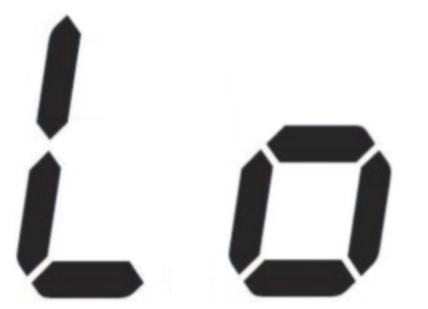」
「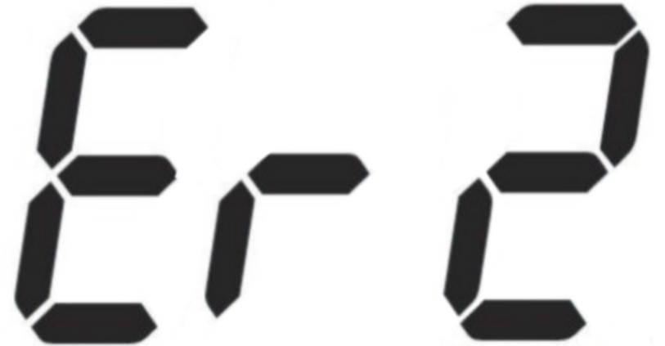」 | ‘Er2’ is displayed when the thermometer is exposed to rapid changes in the ambient temperature. ‘Er3’ is displayed when the ambient temperature of the thermometer EXCEEDS 0°C (32°F) OR +50°C (122°F). In both cases you should allow plenty of time (minimum 30 minutes) for the thermometer to stabilize to the working/room temperature.
「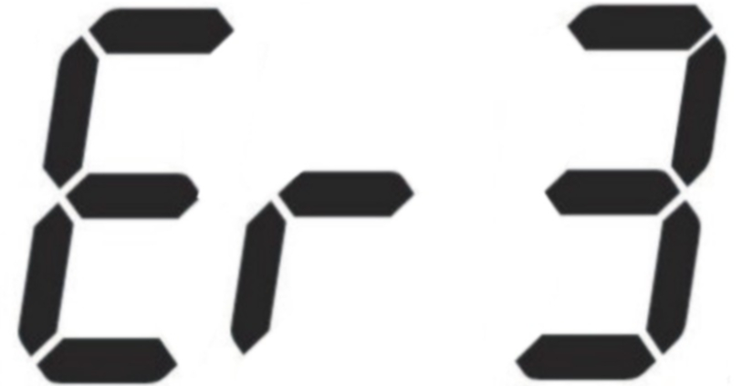」
「」 | For all other error messages it is necessary to reset the thermometer. To reset the thermometer, turn the instrument off, remove the battery and wait for a minimum of one minute, reinsert the battery and turn on. If the error message remains please contact the Service Department for further assistance.

BATTERIES
The thermometer has two separate batteries. The battery closer to the side of the laser beam output is for laser operation only. The other battery is designated for temperature measurements. The thermometer can still measure temperature properly, even without the laser battery.
The thermometer incorporates visual low battery indication (for the lower battery) as follows:
 |  | 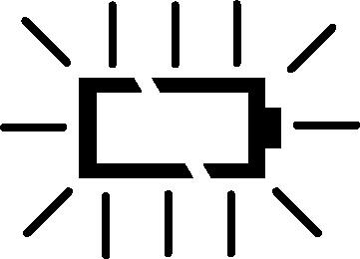
‘Battery OK’: measurements  are possible | ‘Battery Low’: battery needs to be replaced, measurements are possible | ‘Battery Exhausted’:  measurements are  not possible

BATTERY REPLACEMENT
When the ‘Low Battery’ icon indicates the battery is low, the battery should be replaced immediately with a CR2032 lithium cell. The battery is located under the twist cover at the rear of the thermometer. Please note: It is important to turn the instrument off before replacing the battery otherwise the thermometer may malfunction.
Dispose of used battery properly and keep away from children.

STORAGE & CLEANING
The sensor lens is the most delicate part of the thermometer. The lens should be kept clean at all times, care should be taken when cleaning the lens using only a soft cloth or cotton swab with water or medical alcohol, allowing the lens to fully dry before using the thermometer, do not submerge any part of the thermometer. The thermometer should be stored at room temperature between -20 to +65°C (14 to 149°F).

SPECIFICATION
Measurement Range | -55 to +250°C (-67~482°F)
Operating Range | 0~50°C (32~122°F)
Accuracy  (Tobj=15-35°C, Tamb=25°C) | +/-1°C (1.8°F)
Accuracy  (Tobj=-33~250 ºC, Tamb=23±3 ºC) | +/-2% of reading or 2°C (4°F) whichever is greater
Resolution (-9.9~199.9°C) | 0.1°C / 0.1°F (switchable)
Response Time (90%) | 1 second
Distance:Spot | 8:1 optics ratio
Emissivity Range | 0.05~1 Step.01
Battery Life | Typ. 40hr, min 30hr  (auto power off after 15 seconds)
Battery | CR2032 (for Laser, 2pcs required)
Dimensions | 52 x 110 x 22mm
Weight | 82 grams including batteries

EMC/RFI
Readings may be affected if the unit is operated within radio frequency electromagnetic field strength of approximately 3 volts per meter, but the performance of the instrument will not be permanently affected.

GUARANTED
The thermometer is guaranteed for a period of one year from the date of purchase against mechanical and electrical manufacturing defects. There are no user serviceable parts inside the instrument. Any attempted repair by unauthorized persons voids the warranty.

